

MD.070 Application Extensions

Technical Design

2 Degrees

Oracle E Business Suite R12

Integration to Basware

PO.01.12 2D Purchase Order XML File Creation

v1.0

**Dart Arellano**

07 June 2018

Document Control

Document History

|  |  |  |  |
| --- | --- | --- | --- |
| Version | Name | Date | Comment |
| Draft1A | Dart Arellano | 12-June-2018 | Initial version |
| 1.0 | Dart Arellano |  | Approved and released to 2 Degrees |
|  |  |  |  |
|  |  |  |  |

Distribution

|  |  |  |  |
| --- | --- | --- | --- |
| Name | Title/Position | Company | Date |
|  | Library Master | DXC RED ROCK | 12-June-2018 |
| Miles Harvey | Internal Systems Support Lead | 2 Degrees |  |
| John Marais | ePMO Project Manager | 2 Degrees |  |
| Matt Farrer | Project Manager/Consulting Manager | DXC RED ROCK |  |

Reviewers

|  |  |  |  |
| --- | --- | --- | --- |
| Name | Title/Position | Review Date | Reviewed Version |
| Dirk Verbeek | Technical Consultant | 11-June-2018 | Draft1A |
| Matt Farrer | Project Manager/Consulting Manager | 11-June-2018 | Draft1A |

Approval

|  |  |  |  |
| --- | --- | --- | --- |
| Name | Title/Position | Date | Approval |
|  |  |  |  |

Table of Contents

1 Technical Overview 4

1.1 Approach 4

1.2 Module List 4

1.3 Prerequisite 4

1.4 Document Reference 4

2 2D Purchase Order XML File Creation - Concurrent Program Logic 5

2.1 Report Design 5

2.1.1 SQL Queries 5

2.1.2 Data Model 5

2.1.3 Report Groups and Elements 6

2.1.4 Data Links 8

2.1.5 Triggers 8

2.2 Program Executable 9

2.3 Calling Arguments 9

2.4 Incompatibility 9

2.5 Profile Option 9

2.6 Output File 9

2.7 Log File 11

2.8 Related Concurrent Programs 11

3 Database Design 12

3.1 Database Diagram 12

3.2 Database Objects 12

3.2.1 Tables 12

3.2.2 Views 12

4 Installation Instructions 13

4.1 Code Release Cycle 13

5 Implementation Notes 14

5.1 Coding Summary 14

5.2 Program Files 14

5.3 Testing Summary 14

6 Open and Closed Document Issues 15

6.1 Open Issues 15

6.2 Closed Issues 15

# Technical Overview

This document defines the technical components required to implement customisation PO.01.12 2D Purchase Order XML File Creation. This Application Extension Technical Design document complements the Application Extension Functional Design document that addresses PO Import of Basware P2P Solution, consider the set to be the complete detailed design.

## Approach

* Build a report with XML output using Oracle Reports Developer 10g
* Create independent database view for PO Headers, PO Lines, PO Distributions, and Receipt Lines to implement object modularity
* Add a post run report routine to copy the output file from APPLOUT and place it in to the target Basware outbound directory
* Register the Oracle Report as a concurrent program to run overnight on a regular basis

## Module List

|  |  |
| --- | --- |
| Concurrent Program | 2D Purchase Order XML File Creation |

## Prerequisite

The Interface Framework common API delivers a number pre-built functions and procedures regularly used across many interface requirements. Customisation PO.01.12 2D Purchase Order XML File Creation uses some of the accessible functionality offered, hence installation of Interface Framework API is required.

|  |  |
| --- | --- |
| Database Packages | XXFND_COMMON_PKG  XXFND_COMMON_INT_PKG |
| Concurrent Programs | 2D Common Interface Errors Report  2D Common Interface Run Report |

## Document Reference

| Doc ID | File Name | Date | Author |
| --- | --- | --- | --- |
|  |  |  |  |
| IDD 1.15 | Two Degrees Interface Description Document_v1.15.pdf | 05-May-2018 | Raimo Herttua |
| MD.050 (PO Import) | MD 050 Purchase Order Import Functional Specification_V0.2.docx | 11-June-2018 | Jennifer Pole  Vaughn Hunt |

# 2D Purchase Order XML File Creation - Concurrent Program Logic

Concurrent program 2D Purchase Order XML File Creation is a report for extracting Purchasing Document data originally sent by Basware P2P Solution to Oracle. PO extract schedule is incremental but with a back dating option to support flexibility.

## Report Design

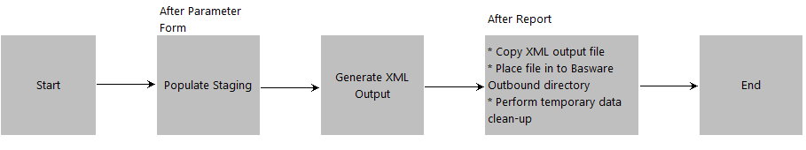

### SQL Queries

Q1_HEADER: Data Group 🡪 G_ORDER

Q2_LINE: Data Group 🡪 G_ORDER_ROWS

Q3_DISTRIBUTION: Data Group 🡪 G_CODING_ROWS

Q4_RECEIPT: Data Group 🡪 G_GOODS_RECEIPTS

### Data Model

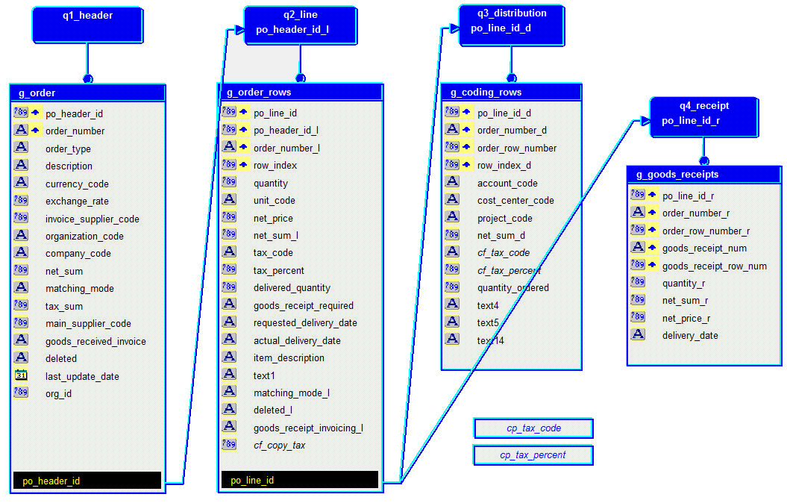

### Report Groups and Elements

| **Group** | **Element: Source Table and Column** | **XML Path** | **Derivation/Comment** |
| --- | --- | --- | --- |
| G_ORDER | PO_HEADERS_ALL.SEGMENT1 | /Orders/Order/OrderNumber |  |
| G_ORDER |  | /Orders/Order/OrderTypeCode | Constant ‘1’ |
| G_ORDER | PO_HEADERS_ALL.COMMENTS | /Orders/Order/Description |  |
| G_ORDER | PO_HEADERS_ALL.CURRENCY_CODE | /Orders/Order/CurrencyCode |  |
| G_ORDER | PO_HEADERS_ALL.RATE | /Orders/Order/ExchangeRate |  |
| G_ORDER | PO_HEADERS_ALL.VENDOR_SITE_ID | /Orders/Order/InvoicingSupplierCode |  |
| G_ORDER | PO_HEADERS_ALL.ORG_ID | /Orders/Order/OrganizationElementCode | DECODE(org_id, 82, '01', 453, 07, 452, 06) |
| G_ORDER | PO_HEADERS_ALL.ORG_ID | /Orders/Order/CompanyCode | DECODE(org_id, 82, '01', 453, 07, 452, 06) |
| G_ORDER | PO_LINES_ALL.UNIT_PRICE  PO_LINES_ALL.QUANTITY | /Orders/Order/NetSum | SUM(unit_price x quantity) |
|  |  | /Orders/Order/MatchingMode | Constant ‘0’ |
| G_ORDER | PO_DISTRIBUTIONS_ALL.RECOVERABLE_TAX | /Orders/Order/TaxSum | SUM(recoverable_tax) |
| G_ORDER | PO_HEADERS_ALL.VENDOR_SITE_ID | /Orders/Order/MainSupplierCode |  |
| G_ORDER |  | /Orders/Order/GoodsReceiptsBasedInvoicing | Constant ‘True’ |
| G_ORDER | PO_HEADERS_ALL.CANCEL_FLAG | /Orders/Order/Deleted | DECODE(NVL(cancel_flag, 'N'), 'Y', '0', '1') |
| G_ORDER_ROWS | PO_HEADERS_ALL.SEGMENT1 | /Orders/Order/OrderRows/OrderRow/OrderNumber |  |
| G_ORDER_ROWS | PO_LINES_ALL.LINE_NUM | /Orders/Order/OrderRows/OrderRow/RowIndex |  |
| G_ORDER_ROWS | PO_LINES_ALL.QUANTITY | /Orders/Order/OrderRows/OrderRow/Quantity |  |
| G_ORDER_ROWS | PO_UNITS_OF_MEASURE_VAL_V.UOM_CODE | /Orders/Order/OrderRows/OrderRow/UnitCode |  |
| G_ORDER_ROWS | PO_LINES_ALL.UNIT_PRICE | /Orders/Order/OrderRows/OrderRow/NetPrice |  |
| G_ORDER_ROWS | PO_LINE_LOCATIONS_ALL.PRICE_OVERRIDE | /Orders/Order/OrderRows/OrderRow/NetSum |  |
| G_ORDER_ROWS | FND_LOOKUP_VALUES.TAG  ZX_LINES.TAX_RATE_ID | /Orders/Order/OrderRows/OrderRow/TaxCode |  |
| G_ORDER_ROWS | ZX_RATES_VL.PERCENTAGE_RATE | /Orders/Order/OrderRows/OrderRow/TaxPercent |  |
| G_ORDER_ROWS | PO_LINES_ALL.QUANTITY | /Orders/Order/OrderRows/OrderRow/DeliveredQuantity |  |
| G_ORDER_ROWS |  | /Orders/Order/OrderRows/OrderRow/GoodsReceiptRequired | Constant ‘True’ |
| G_ORDER_ROWS | PO_LINE_LOCATIONS_ALL.NEED_BY_DATE | /Orders/Order/OrderRows/OrderRow/RequestedDeliveryDate |  |
| G_ORDER_ROWS | RCV_TRANSACTIONS.TRANSACTION_DATE | /Orders/Order/OrderRows/OrderRow/ActualDeliveryDate |  |
| G_ORDER_ROWS | PO_LINES_ALL.ITEM_DESCRIPTION | /Orders/Order/OrderRows/OrderRow/Description |  |
| G_ORDER_ROWS | MTL_SYSTEM_ITEMS_B.SEGMENT1 | /Orders/Order/OrderRows/OrderRow/Text1 |  |
| G_ORDER_ROWS |  | /Orders/Order/OrderRows/OrderRow/MatchingMode | Constant ‘0’ |
| G_ORDER_ROWS | PO_LINES_ALL.CANCEL_FLAG | /Orders/Order/OrderRows/OrderRow/Deleted | DECODE(NVL(cancel_flag, 'N'), 'Y', '0', '1') |
| G_ORDER_ROWS |  | /Orders/Order/OrderRows/OrderRow/GoodsReceiptsBasedInvoicing | Constant ‘True’ |
| G_ORDER_ROWS |  | /Orders/Order/OrderRows/OrderRow/OverReceivalAllowed | Constant ‘False’ |
| G_CODING_ROWS | PO_HEADERS_ALL.SEGMENT1 | /Orders/Order/OrderRows/OrderRow/CodingRows/CodingRow/OrderNumber |  |
| G_CODING_ROWS | PO_LINES_ALL.LINE_NUM | /Orders/Order/OrderRows/OrderRow/CodingRows/CodingRow/OrderRowNumber |  |
| G_CODING_ROWS | PO_DISTRIBUTIONS_ALL.DISTRIBUTION_NUM | /Orders/Order/OrderRows/OrderRow/CodingRows/CodingRow/RowIndex |  |
| G_CODING_ROWS | GL_CODE_COMBINATIONS.SEGMENT4 | /Orders/Order/OrderRows/OrderRow/CodingRows/CodingRow/AccountCode |  |
| G_CODING_ROWS | GL_CODE_COMBINATIONS.SEGMENT3 | /Orders/Order/OrderRows/OrderRow/CodingRows/CodingRow/CostCenterCode |  |
| G_CODING_ROWS | GL_CODE_COMBINATIONS.SEGMENT5 | /Orders/Order/OrderRows/OrderRow/CodingRows/CodingRow/ProjectCode |  |
| G_CODING_ROWS | PO_LINES_LOCATIONS_ALL.PRICE_OVERRIDE | /Orders/Order/OrderRows/OrderRow/CodingRows/CodingRow/NetSum |  |
| G_CODING_ROWS | FND_LOOKUP_VALUES.TAG  ZX_LINES.TAX_RATE_ID | /Orders/Order/OrderRows/OrderRow/CodingRows/CodingRow/TaxCode |  |
| G_CODING_ROWS | ZX_RATES_VL.PERCENTAGE_RATE | /Orders/Order/OrderRows/OrderRow/CodingRows/CodingRow/TaxPercent |  |
| G_CODING_ROWS | PO_DISTRIBUTIONS_ALL.QUANTITY_ORDERED | /Orders/Order/OrderRows/OrderRow/CodingRows/CodingRow/Quantity |  |
| G_CODING_ROWS | GL_CODE_COMBINATIONS.SEGMENT6 | /Orders/Order/OrderRows/OrderRow/CodingRows/CodingRow/Text4 |  |
| G_CODING_ROWS | PO_DISTRIBUTIONS_ALL.ATTRIBUTE1 | /Orders/Order/OrderRows/OrderRow/CodingRows/CodingRow/Text5 |  |
| G_CODING_ROWS | GL_CODE_COMBINATIONS.SEGMENT2 | /Orders/Order/OrderRows/OrderRow/CodingRows/CodingRow/Text14 |  |
| G_GOODS_RECEIPTS | PO_HEADERS_ALL.SEGMENT1 | /Orders/Order/OrderRows/OrderRow/GoodsReceipts/GoodsReceipt/OrderNumber |  |
| G_GOODS_RECEIPTS | PO_LINES_ALL.LINE_NUM | /Orders/Order/OrderRows/OrderRow/GoodsReceipts/GoodsReceipt/OrderRowNumber |  |
| G_GOODS_RECEIPTS | RCV_SHIPMENT_HEADERS.RECEIPT_NUM | /Orders/Order/OrderRows/OrderRow/GoodsReceipts/GoodsReceipt/GoodsReceiptNumber |  |
| G_GOODS_RECEIPTS | RCV_SHIPMENT_LINES.LINE_NUM | /Orders/Order/OrderRows/OrderRow/GoodsReceipts/GoodsReceipt/GoodsReceiptRowNumber |  |
| G_GOODS_RECEIPTS | RCV_TRANSACTIONS.QUANTITY | /Orders/Order/OrderRows/OrderRow/GoodsReceipts/GoodsReceipt/Quantity |  |
| G_GOODS_RECEIPTS | RCV_TRANSACTIONS.QUANTITY  PO_LINES_ALL.UNIT_PRICE | /Orders/Order/OrderRows/OrderRow/GoodsReceipts/GoodsReceipt/NetSum |  |
| G_GOODS_RECEIPTS | PO_LINES_ALL.UNIT_PRICE | /Orders/Order/OrderRows/OrderRow/GoodsReceipts/GoodsReceipt/NetPrice |  |
| G_GOODS_RECEIPTS | RCV_SHIPMENT_LINES.PROGRAM_UPDATE_DATE | /Orders/Order/OrderRows/OrderRow/GoodsReceipts/GoodsReceipt/DeliveryDate |  |

### Data Links

G_ORDER: PO_HEADER_ID 🡪 Q2_LINE: PO_HEADER_ID

G_ORDER_ROWS: PO_LINE_ID 🡪 Q3_DISTRIBUTION: PO_LINE_ID

G_ORDER_ROWS: PO_LINE_ID 🡪 Q4_RECEIPT: PO_LINE_ID

### Triggers

After Parameter Form Populate PO Document References staging table by calling the database package xxpo_purchase_order_pkg.create_po_xml.

After Report (1) Copy report output file in to the target Basware outbound directory by calling database package xxfnd_common_pkg.file_copy. (2) Perform clean-up of temporary data.

## Program Executable

| Field | Value |
| --- | --- |
|  |  |
| Executable | XXPOBASXML |
| Short Name | XXPOBASXML |
| Application | XXNZCL Custom Application |
| Description | 2D Basware Purchase Order XML File Creation |
| Execute Method | PL/SQL Stored Procedure |
| Execute File Name | xxpo_purchase_order_pkg.create_po_xml |

## Calling Arguments

| Argument | Prompt | Value Set | Default Value |
| --- | --- | --- | --- |
|  |  |  |  |
| p_source | Order Source | 30 Characters | Constant: Basware |
| p_last_run_date | Last Run Datetime | FND_STANDARD_DATETIME | SQL:  SELECT TO_CHAR(MAX(last_run_date), 'DD-MON-YYYY HH24:MI:SS') FROM xxfnd_interface_stg WHERE object_type = 'ORDER' AND in_out = 'OUT' AND status = 'CREATED' |
| p_debug_on | Debug On | Yes_No | Constant: No |

## Incompatibility

| Application | Name | Scope | Type |
| --- | --- | --- | --- |
|  |  |  |  |
| XXNZCL Custom Application | 2D Basware Purchase Order XML File Creation | Program | Domain |

## Profile Option

| Name | Level | Value Set | Default Value |
| --- | --- | --- | --- |
|  |  |  |  |
| 2D Outbound Directory for Basware | Site | n/a | /basware/outbound |
| 2D Notification Email Address for BW Interfaces | Site | n/a | email@email.com |

## Output File

PO Import XML Output file

<?xml version="1.0" encoding="UTF-8"?>

<!-- Generated by Oracle Reports version 10.1.2.3.0 -->

<Orders>

<Order>

<OrderNumber>011800028</OrderNumber>

<OrderTypeCode>1</OrderTypeCode>

<Description>Test order num 011800028</Description>

<CurrencyCode>NZD</CurrencyCode>

<ExchangeRate></ExchangeRate>

<InvoicingSupplierCode>278197</InvoicingSupplierCode>

<OrganizationalElementCode>01</OrganizationalElementCode>

<CompanyCode>01</CompanyCode>

<NetSum>21.5</NetSum>

<MatchingMode>0</MatchingMode>

<TaxSum>2.69</TaxSum>

<MainSupplierCode>278197</MainSupplierCode>

<GoodsReceivedBasedInvoicing>True</GoodsReceivedBasedInvoicing>

<Deleted>1</Deleted>

<OrderRows>

<OrderRow>

<OrderNumber>011800028</OrderNumber>

<RowIndex>1</RowIndex>

<Quantity>1</Quantity>

<UnitCode>EA</UnitCode>

<NetPrice>21.5</NetPrice>

<NetSum>21.5</NetSum>

<TaxCode>GST-12.5%</TaxCode>

<TaxPercent>12.5</TaxPercent>

<DeliveredQuantity>1</DeliveredQuantity>

<GoodsReceiptRequired>True</GoodsReceiptRequired>

<RequestedDeliveryDate>2018-05-30T00:00:00</RequestedDeliveryDate>

<ActualDeliveryDate></ActualDeliveryDate>

<Description>This is the item description</Description>

<Text1></Text1>

<MatchingMode>0</MatchingMode>

<Deleted>1</Deleted>

<GoodsReceiptsBasedInvoicing>True</GoodsReceiptsBasedInvoicing>

<GoodsReceipts>

</GoodsReceipts>

<CodingRows>

<CodingRow>

<OrderNumber>011800028</OrderNumber>

<OrderRowNumber>1</OrderRowNumber>

<RowIndex>1</RowIndex>

<AccountCode>149999</AccountCode>

<CostCenterCode>1738</CostCenterCode>

<ProjectCode>IT17_WEBDV</ProjectCode>

<NetSum>21.5</NetSum>

<Quantity>.6</Quantity>

<Text4>EI85</Text4>

<Text5>Opex</Text5>

<Text14>999</Text14>

<TaxCode>GST-12.5%</TaxCode>

<TaxPercent>12.5</TaxPercent>

</CodingRow>

<CodingRow>

<OrderNumber>011800028</OrderNumber>

<OrderRowNumber>1</OrderRowNumber>

<RowIndex>2</RowIndex>

<AccountCode>720105</AccountCode>

<CostCenterCode>1553</CostCenterCode>

<ProjectCode>9999999999</ProjectCode>

<NetSum>21.5</NetSum>

<Quantity>.4</Quantity>

<Text4>9999</Text4>

<Text5>Opex</Text5>

<Text14>999</Text14>

<TaxCode>GST-12.5%</TaxCode>

<TaxPercent>12.5</TaxPercent>

</CodingRow>

</CodingRows>

</OrderRow>

</OrderRows>

</Order>

</Orders>

## Log File

n/a

## Related Concurrent Programs

* 2D Basware Purchase Order XML File (sub-request)
* 2D Basware PO Import (sub-request)

# Database Design

This section summarized new and changed database objects and data required to implement PO.01.12 2D Purchase Order XML File Creation.

## Database Diagram

Data model shown on section 2.1.2 of this document depicts the relationship between the business object entities.

## Database Objects

### Tables

Custom table definition to support customisation PO.01.12 2D Purchase Order XML File Creation

* XXPO_DOCUMENT_REFERENCES
* XXPO_DOCUMENT_REFERENCES_STG

### Views

* XXPO_HEADERS_XML_V
* XXPO_LINES_XML_V
* XXPO_DISTRIBUTIONS_XML_V
* XXPO_RECEIPTS_XML_V

# Installation Instructions

An automated installation script is provided to migrate customisation PO.01.12 2D Purchase Order XML File Creation to the target environment.

Step 1: Place the TAR file PO.01.12-R-[release number].tar in $XXNZCL_TOP directory of the target environment (binary mode)

Step 2: Extract the contents of the TAR file

> cd $XXNZCL_TOP

> tar -xvf PO.01.12-R-[release number].tar

Step 3: Run the install script

> cd install

> chmod +x PO.01.12_install.sh

> ./PO.01.12_install.sh [db password] | tee PO.01.12_install.[release number].log

## Code Release Cycle

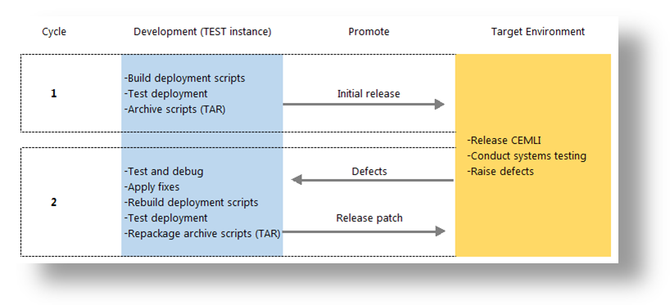

# Implementation Notes

This document describes exactly how PO.01.12 2D Purchase Order XML File Creation was developed and implemented at 2 Degrees.

## Coding Summary

Development was done on Linux 2.6.32-431.el6.i686 server, host name snzclakl025.nzc.co.nz, to work with Release 12.1.3 of Oracle Applications. All coding follows the standards defined in Oracle E Business Suite Developer’s Guide Part No. E12897-4.

## Program Files

| Type | Name | Location |
| --- | --- | --- |
|  |  |  |
| DDL | XXPO_HEADERS_XML_V_DDL.sql | $XXNZCL_TOP/install/sql |
| DDL | XXPO_LINES_XML_V_DDL.sql | $XXNZCL_TOP/install/sql |
| DDL | XXPO_DISTRIBUTIONS_XML_V_DDL.sql | $XXNZCL_TOP/install/sql |
| DDL | XXPO_RECEIPTS_XML_V_DDL.sql | $XXNZCL_TOP/install/sql |
| Loader | XXPOBASXML.ldt | $XXNZCL_TOP/import |
| Loader | XXPOEPOXML.ldt | $XXNZCL_TOP/import |
| Loader | XXPOREQGRP.ldt | $XXNZCL_TOP/import |
| Loader | XXADMREQGRP.ldt | $XXNZCL_TOP/import |
| Report | XXPOEPOXML.rdf | $XXNZCL_TOP/reports/US |
| Install Script | PO.01.12_install.sh | $XXNZCL_TOP/install |

## Testing Summary

The customizations were tested in 2 Degrees' snzclakl025.nzc.co.nz TEST environment before promoting to the next target environment. See the related functional test scripts for more information.

# Open and Closed Document Issues

## Open Issues

|  |  |  |  |  |  |
| --- | --- | --- | --- | --- | --- |
| ID | Issue | Resolution | Responsibility | Target Date | Impact Date |
| 1. |  |  |  |  |  |
| 2. |  |  |  |  |  |

## Closed Issues

|  |  |  |  |  |  |
| --- | --- | --- | --- | --- | --- |
| ID | Issue | Resolution | Responsibility | Target Date | Impact Date |
| 1. |  |  |  |  |  |
| 2. |  |  |  |  |  |
| 3. |  |  |  |  |  |
| 4. |  |  |  |  |  |